# 

**MSc Web and Mobile Development Technologies**

**Web Engineering LD7025**

# 

**Pizza Delivery System Project**

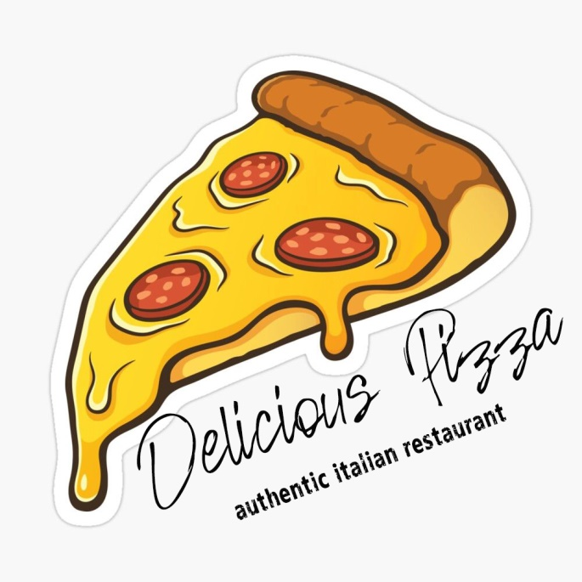

**Student: Nicoleta Mezei**

# INTRODUCTION

The main goal of this project is to change way of restaurants business by allowing customers to order food items online and will be delivered to customers place.

Delicious Pizza is an authentic Italian restaurant located in Spitalfields, London. They are serving various kinds of pizza having Neapolitan origins. Delicious Pizza needs a pizza ordering system to meet the client's requirements for delivery.

## Business requirements

* The take-away new service that replaces the dine-in service, requires an online ordering system
* Responsive website that can automate the ordering and delivery process
* Display promotions and products catalog
* Users must register in two categories: restaurant staff or customer
* Staff should be able to see and delete customer orders
* The restaurant owner (admin) should be able to register view and delete user information

## User requirements

* Place the order and track delivery
* Secured login in to personal account
* Search for preferred product
* Payment online
* Self-registration function
* Multiple option choices for every product
* Order tracking

# Part 1 – Research

## Contemporary web development technologies

Delicious Pizza is an authentic Italian restaurant with a dine-in service. Due to the COVID-19 pandemic, all the restaurants are struggling to save their businesses, being the uncertain times as the pandemic continues to keep closed all the shops, gyms, and restaurants where people are used to meeting and socialize. Since customers are staying home, online businesses are less affected. For Delicious pizza, this idea is more attractive because it overcomes geographical limitations to reach more customers, and the impact of technology on the food industry has been revolutionary in the last few years. A lot of delivery apps are on market such as UberEats, Deliveroo, and so on. A good online presence will help to build trust and achieve more customers and many other advantages for the future. Open the restaurant for the public is not possible at the moment and after the pandemic, the people's interaction with restaurants will be different or maybe the new rules will not be as we expected until we get back to normal.

Web Presence and interaction with the real world

The internet has became present in every aspect of our lives, changing or human interaction day-to day. Ordering pizza, order a uber, sharing moments with friends, socialising and dating, online school and job interviews…

Before the internet if you needed to find an information was necessary to buy a newspaper, if you needed to find a job you were going in person with the CV printed or hand-writted, the messages and letters were via Post Office.

Now the web application are present everywere, the biggest impact that moves everything online was the fist pandemic lockdown from March 2020, when every business was needed to develop a system to continue the activity online.

# Part 2 – Design

### 

The system design must follow the Z and F reading pattern. All the information shown must not be missed by the end-user.

Placing the most important page elements along visitors’ natural eye paths, ensures you create an enganging experience.

### Personas

As long our system will be developed for users needs we need to understand the user persona. What they are interested in, what are they behaviour while ordering food. Users are persona portraits. Our order system is designed for

The following types of users as:

* Admin –he has all the privileges
* Employee- is the delivery boy or delivery agent
* Restaurant Owner- he can manage the orders, can cancel or add items on website
* Customer- he can manage his account after is registered

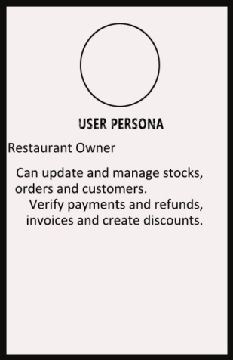 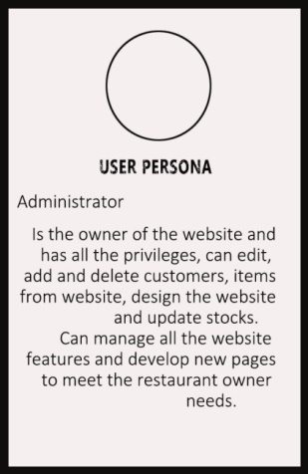

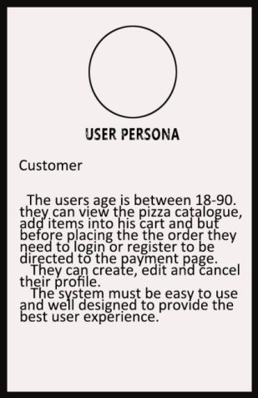 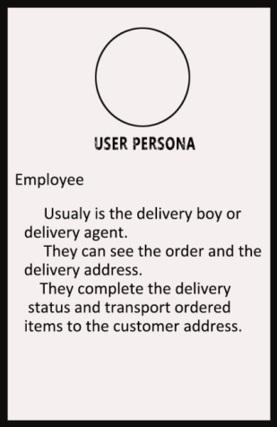

***Figure 1****.*Users as the persona portrays

## Identity Design and colour choices

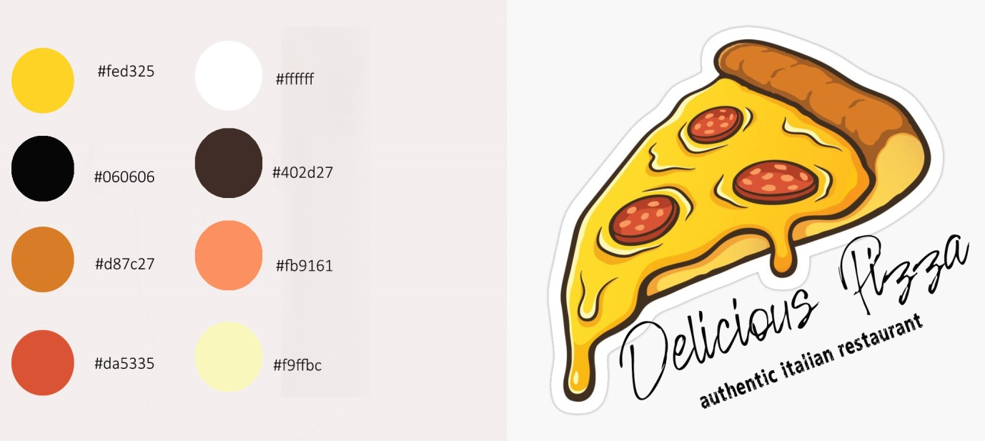

***Figure 2****.* Logo

Fonts:

White funky rabbit-Logo description

Rosiane- Logo title

### Site Architecture Diagram

UI flow chart design to make it easy for the user to navigate across the website in a logical manner. Starting point Home/Index page, enabling user to go to the other 4 websites by linking navigation system. Presenting activities and clubs followed to membership page, Spa facilities and finally contact for queries.

|  |
| --- |
|  |

***Figure 9****.* UI flow diagram/site architecture diagram

### Low Fidelity Wireframes/sketches

|  |  |  |
| --- | --- | --- |
| Initial sketches Homepage | Product service offered/activities club page | Spa page |
|  |  |  |
|  |  |  |

***Figure 10.***Low fidelity wireframes/sketches

### Wireframes

|  |  |  |
| --- | --- | --- |
| Index.html - Desktop | Tablet | Mobile |
|  |  |  |

**Figure 11**. Index wireframes

|  |  |  |
| --- | --- | --- |
| Activities & Clubs - Desktop | Tablet | Mobile |
|  |  |  |

***Figure 12****.* Activities and clubs wireframes

|  |  |  |
| --- | --- | --- |
| Membership - Desktop | Tablet | Mobile |
|  |  |  |

***Figure 13.***Membership wireframes.

|  |  |  |
| --- | --- | --- |
| SPA - Desktop | Tablet | Mobile |
|  |  |  |

***Figure 14****.* Spa wireframes

|  |  |  |
| --- | --- | --- |
| Contact Us - Desktop | Tablet | Mobile |
|  |  |  |

***Figure 15****.* Contact wireframe

## Accessibility and Usability

### Accessibility

|  |  |
| --- | --- |
| Navigation by not only means of colour | Typography size and contrast |
|  |  |

***Figure 16****.* Navigation by not only means of colour

Ideal scenario for all websites should be to allow all users regardless of their technical skills, impairments or disabilities to fully access all the information and functionalities. Nowadays a reasonably high percentage of the population suffers visual impairments, colour blindness, motor disabilities or other sorts or simply aging population, therefore in order to make the website as accessible as possible minimum standards aim to be met ,only as an ethical means but also because is the law, all websites have to be compliant.

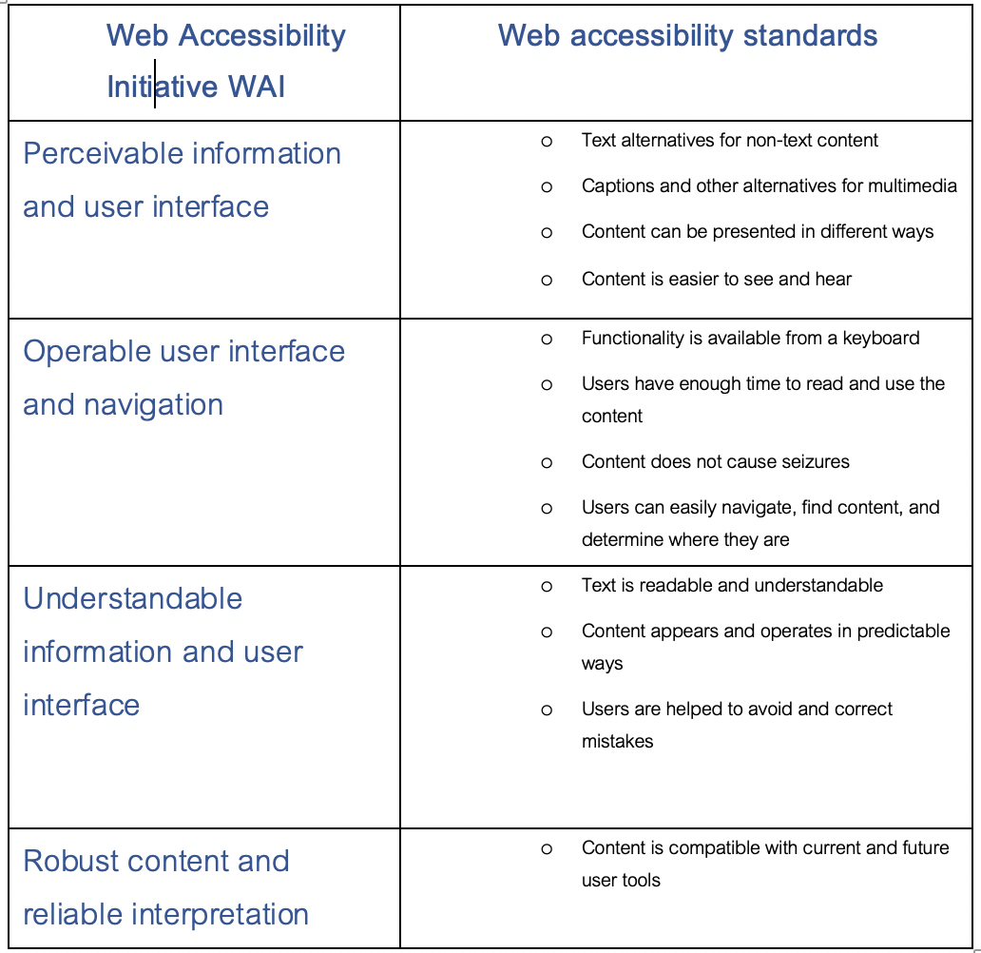

***Figure 17.***Web Accessibility Initiative (WAI) and Web accessibility standards (Abou_Zahra, 2019).

Within the Accessibility Conformance levels there are different degrees. Ranging from A to AAA, defining or grading the level of accessibility the website allows, the more A’s the website accomplishes the more accessible, with the ultimate goal of including as many users as possible as well as meeting and without compromising project requirements and design (Abou_Zahra, 2019).

There will be cases  where the design could not be fully achieved, depending certain accessibility implementations. Therefore, in terms of accessibility conformance, the aim is to achieve Conformance Level AA as a minimum standard, and as many AAA features as possible, enabling a very high percentage of users to fully access the site and its functionalities (Abou_Zahra, 2019).

The aim at designing Fit4All website was to make it Conformance Level AA and implement as many AAA accessibility features as possible, all images have alt descriptions, navigation bar and footer elements informs users of item being clicked by underliningfeature as well as in terms of contrast the colour scheme and typography legibility and size has been chosen in order to maximise the readability. Using section header and heading tags to differentiate hierarchy and manage information groups in order to technologies to determine structure. And HTML has been validated in order to make it syntactically correct, have start and end tags and tags are nested.

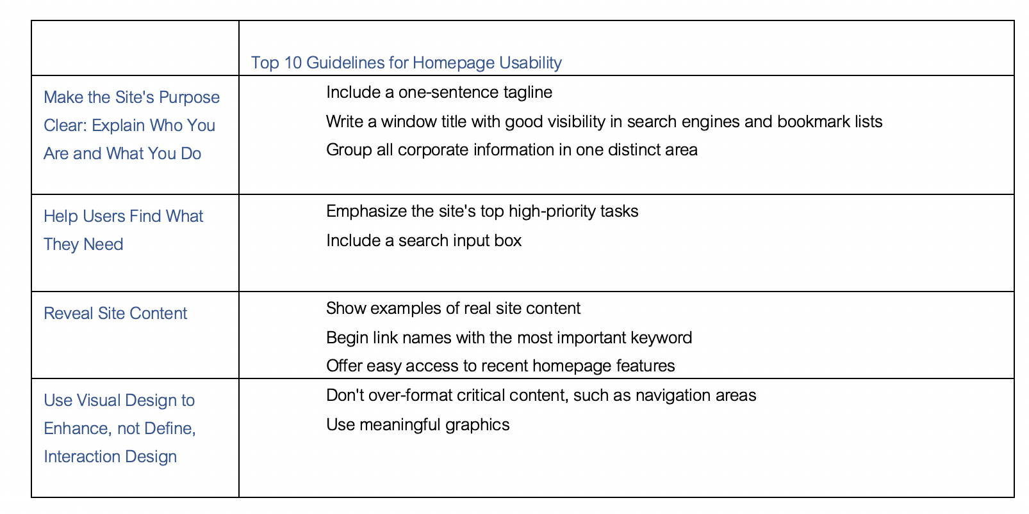

**Figure 18.** Top 10 guidelines for homepage usability (Nielsen, 2002).

# Part 3 – Development

To develop the website several functionalities where implemented, the website is fully navigable trough the navigation bar which enables the user to go to the page required and in order to accomplish that html codding and css styling were used. The index page welcomes the user with a slide show banner which was achieved with JS implementation by rotating a set of 3 banners every 4 seconds to add interactivity and it also enable the user to stop banner by placing the cursor on the banner.

The membership page development was achieved by using PHP in order to link the website to the underlining database unn_w17046281 where customer data and sports centre’s services data should be stored and retrieved when requested. Within the same page the user has the option to access sign up form or sign in to the login area. Login as a user or admin was enabled in order to direct each user to the relevant functionalities required by the specific type of user.

The development of Sign up enables the user to fill a sign up form and submit it in the database which is validated and stored, once the customer is on the database having completed correctly the sign up form whenever signing in the username and password which is hashed in the database will be checked and validated in order to allow the user to login.

Within the contact page a query php form was implemented to enable user to contact sports centre, once the compulsory fields are filled the form enables user to send a query which is sent to the sport centre’s email address and customers gets a thank you message once the form is submitted. In order to make the website more usable several functions were implemented on contact page, google map functionality and telephone prompt to allow user to get access to the relevant sections.

## Tools

### Visual Studio Code

Is an open source program text editor used to build this websites which is the tool used to code Pizza Delivery System.

GitHub + Gitbash

GitHub is one of the world’s largest platform that host source code of developers, a community that allows to share and communicate between developers.

Html 5 Boilerplate

Is a set of files that provide a good foundation to start a new website.

### Bootstrap

**Bootstrap** is a Javascript framework using the grid system used to create responsive layouts in web design. Is the most popular framework used by develpers.

# Development

### Website

|  |
| --- |
| **URL:** |
| [**http://unn-w17046281.newnumyspace.co.uk/index.php**](http://unn-w17046281.newnumyspace.co.uk/index.php) |

***Figure 19.***Site URL

### Folder Structure

|  |  |
| --- | --- |
| Public Folder/.php files | Includes/inc.php files |
|  |  |

***Figure 20****.*Folder structure

### index.html

|  |  |
| --- | --- |
| JavaScript code | Website/Banner |
|  |  |

***Figure 21.***Index html

### Activities and clubs.php

### Services offered by sports centre displayed in form of gallery and lightbox – gallery implementation

|  |  |  |
| --- | --- | --- |
| Activitiesandclubs.php | Gallery | Lightbox/modalbox |
|  |  |  |

***Figure 22****.* Activities and clubs php

### Membership.php

|  |
| --- |
| membership |
|  |

***Figure 23****.* Membership

### Spa.php – video functionality

Spa page advertises the spa facilities in the sports centre and showcases a youtube video functionality allowing the user to open the video and play it.

|  |  |
| --- | --- |
| Spa.php | video |
|  |  |

***Figure 24.***Spa php

### Contact.php

|  |  |  |
| --- | --- | --- |
| Contact | Contact.php | Contact.inc.php |
|  |  |  |

***Figure 25.***Contact php

### Navigation

|  |
| --- |
| Navigation bar |
|  |

***Figure 26.***Navigation bar

Basic navigation template inherited form bootstrap however adjusted to fit the requirements of the project and design wireframes and identity of the sports centre. Bellow as seen on figures on html navigation bar created and on css file element adjustment to fit design.

|  |  |
| --- | --- |
| Html code | Css code |
|  |  |

***Figure 27.*** Navigation bar html

### Footer

Basic footer template inherited form bootstrap however adjusted to fit the requirements of the project and design wireframes and identity of the sports centre. Bellow as seen on figures in the same way of the navigation bar on html footer created and on css file element adjustment to fit design.

|  |
| --- |
| Footer |
|  |

**Figure 28**. Footer

|  |
| --- |
| Html code |
|  |

***Figure 29.*** Footer html

# Header and footer

The function of header and footer in php

|  |  |
| --- | --- |
| header.php | footer.php |
|  |  |

***Figure 30.***Header and footer php

## Forms

### Forms

### Database design

|  |
| --- |
| Database design |
|  |

***Figure 31.***Database design

|  |  |
| --- | --- |
| Database design |  |
|  |  |

***Figure 32.***Database design II

### Contact form

The contact form is a mechanism that has been designed to enable the users to query and request information to the sports centre administration. Through a form coded on contact.html and PHP the user can send a request which is sent to the sports centre email address and once sent it the user gets a thank you for contacting message as seen on below images

|  |
| --- |
| Contact form |
|  |

***Figure 33.***Contact form

|  |  |
| --- | --- |
| Html code | Php script |
|  |  |

***Figure 34.***Contact form html

|  |  |
| --- | --- |
| Message | email |
|  |  |

***Figure 35.***Message and email

### Sign Up form

|  |  |  |
| --- | --- | --- |
| .html | .php | .inc.php |
|  |  |  |

***Figure 36.***Sign up form

### Login form

|  |  |
| --- | --- |
| Html form | login.inc.php |
|  |  |

***Figure 37.***Login form

### Logout form

|  |  |
| --- | --- |
| .html | logout.inc.php |
|  |  |

***Figure 38.***Logout form

### Database and Authentication

Password hashing-code

### Users - User functionalities

Through membership’s page the users can login as sport centre as user or admin. By selecting the user type the user would be directed to the relevant page, the sports centre user or customer would be directed to the welcome.php where users would be able to change membership details and book activities and classes and Admin user would be directed to sports centre’s admin dashboard page admin.php where admin user would be able to update user memberships.

|  |
| --- |
| **Username: test** |
| **Password: 12345** |

### Part 4 – Testing

## HTML, CSS and PHP validation and optimization process

### W3School validation

In order to validate the html and css code Nu Html checker was used in each page containing html code. As part of accessibility all code needs to be validated. As seen on figure below, errors were identified and sorted accordingly to validate code, in the specific example as shown the Nu Html Checker pointed at the error of an attribute element that should have not been on the specific line of code. Once identified on the original document was removed and once again run in the Nu Html checker with an error free outcome.

### Specific validation examples

|  |  |  |
| --- | --- | --- |
| Error | Amendment | Validation |
|  |  |  |

***Figure 39.***Specific validation examples

### Devices- Accessibility, usability, cross-browser and cross-platform

As part of the testing the website has been optimized and tested in different browsers, devices and platforms as seen on figures below.

### Laptop and Mac

|  |
| --- |
| Laptop |
|  |

***Figure 40.***Laptop

|  |
| --- |
| Mac |
|  |

***Figure 41.***Mac

### Ipad and Tablet

|  |  |
| --- | --- |
| Ipad | Tablet |
|  |  |

***Figure 42.***Ipad and Tablet

### Android and IOS

|  |  |
| --- | --- |
| Android Galaxy S5 | iOS 5,6,7 |
|  |  |

***Figure 43.***Android and IOS

### 

### Browsers

|  |  |  |
| --- | --- | --- |
| Chrome | Firefox | Safari |
|  |  |  |

***Figure 44.***View in three different browsers

### Critically appraise ethical issues in accessibility and web development

It Is ethically correct to make websites as accessible as possible to reach the highest possible level of accessibility in terms of compatibility and specially conformance however, the accessibility issue is still very present as unfortunately most of the websites don’t meet the basic requirements.

With the aging population and people with disabilities using websites and applications on an everyday basis web developers and companies creating websites and acquiring websites should develop and demand the implementation of basic accessibility standards. Whether is due to the fact that implementing accessibility might be time consuming or a compromise in some way in terms of the design of the sites is not acceptable. By not making sites available to everyone a percentage of population is being excluded.

# **Bibliography**

<https://blog.fluidui.com/how-user-personas-will-make-your-prototypes-better/>

<https://99designs.co.uk/blog/tips/branding-colors/>

<https://www.w3schools.com/>

<https://getbootstrap.com/>

<https://html5boilerplate.com/>